**KMSmicro v3.10 BY Ratiborus for Microsoft** [**Office**](javascript:void(0);) **2013 And Windows 8**



This is The MicroKMS Activator and KMSmicro v3.10 BY Ratiborus [Finally Working KMS Activation [Office](javascript:void(0);) 2013 VL on Windows 8].

Stand-alone, independent of the system, a local KMS server to activate Windows 7, Windows 8 Professional and Enterprise versions, and with this version and Office 2010 and 2013. You can use a stick.

**READ THIS !!!**

**KMSmicro v3.10 activate** [**Microsoft Office**](http://www.clicksor.com) **2013 Volume Edition Only [Not for retail]**

**After Succefully activate you get 180 days then repeat the activation there after.**

**Instruction**

A. Activating  already installed Office 2013

1. Run KMSmicro (Admin [Privilege](javascript:void(0);)) and  select Run NetTime (T)

[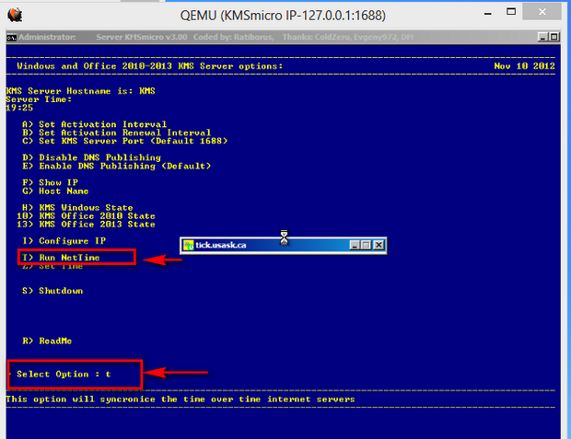](http://4.bp.blogspot.com/--Ocxc3LWqZE/UKEzj8mtPoI/AAAAAAAAECc/j5_Tlcbqgd0/s1600/20121111193014copy.png)

2. Run one of the following cmd-file on behalf of the Administrator:

Office 2010 Activate.[bat](javascript:void(0);) Office 2010-x32 & Windows-x32 or Office 2010-x64 & Windows-x64

Office 2010 (w64-o32) Activate.[bat](http://www.clicksor.com) Office 2010-x32 & Windows-x64

Office 2013 Activate.bat Office 2013-x32 & Windows-x32 or Office 2013-x64 & Windows-x64

Office 2013 (w64-o32) Activate.bat Office 2013-x32 & Windows-x64.

3. If the end of a saw «<Product activation successful>», the product is activated / activating extended.

[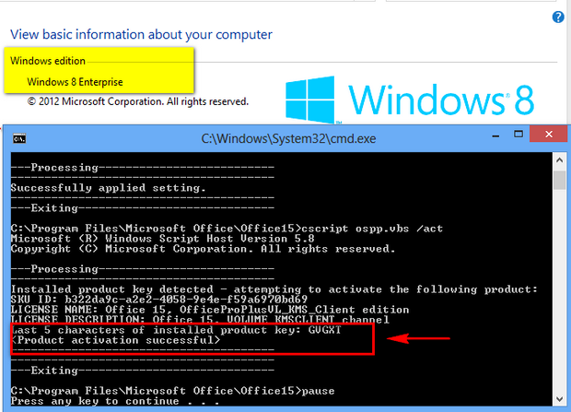](http://2.bp.blogspot.com/-xW5HLPQL8nI/UKEzqA4QfhI/AAAAAAAAECk/VLS760oKlgI/s1600/20121111193201copy.png)

4. Close KMSmicro (S)

**Supported System**

• Microsoft Office 2013

• Microsoft [Office Visio](javascript:void(0);) 2013

• Microsoft [Office Project](javascript:void(0);) 2013

• Windows 8 Enterprise

• Windows 8 Professional

• Microsoft Office 2010

• Microsoft [Office Project](javascript:void(0);) 2010

• Microsoft Office Project 2010

• Windows 7 Enterprise

• Windows 7 Professional

**B. Activating if you did not installed Office 2013 yet:**

1. Run KMSmicro (Admin [Privilege](javascript:void(0);)) and  select Run NetTime (T)

2. Import the registry required data. Double-click on the file:

Office2010-Localhost.reg when you install Office 2010;

Office2013-Win7-Localhost.reg when you install Office 2013 on Windows 7;

Office2013-Win8-Localhost.reg when you install Office 2013 on Windows 8.

3. Install Office | Visio | Project VL.

4. Run the application and check the status of activation. If you suddenly see that require activation, close the application, wait for 1-2 minutes

   and check the status of the activation again.

   Rarely, but it happens. Usually the product is activated immediately after installation

5. Close KMSmicro (S)

**If activation fails**

1. You are trying to activate the Retail version of the product

2. Wall / antivirus blocking communication

3. Expired meter unique activation requests. Check the status of input 10 to Office 2010 or Office 13 to 2013. Value «Current count» must be at least 4. If you see a lower value, so it is necessary to wind counters. But that's another story!

This sets the desired KMS server. Activation should proceed automatically with no further intervention required. However, to force activation immediately type the following command:

* For 32-bit Windows : **cscript "C:\Program Files\Microsoft Office\Office15\OSPP.VBS" /act**
* For 64-bit Windows: **cscript "C:\Program Files (x86)\Microsoft Office\Office15\OSPP.VBS" /act**

The cmd.exe command is elevated. On the cmd.exe interface short-cut menu (right-click), choose **Run as administrator**.

The following table describes the ospp.vbs global options.

**Global options for ospp.vbs**

|  |  |
| --- | --- |
| **Global option** | **Description** |
| */act* | Activates installed Office 2013 product keys. |
| */inpkey:value* | Installs a product key (replaces existing key) with user-provided product key. Value option is required. |
| */unpkey:value* | Uninstalls an installed product key with the last five digits of the product key to uninstall (as displayed by the */dstatus* option). Value parameter is required. |
| */inslic:value* | Installs a license with user-provided path of the .xrm-ms license. Value parameter is required. |
| */dstatus* | Displays license information for installed product keys. |
| */dstatusall* | Displays license information for all installed licenses. |
| */dhistoryacterr* | Displays the failure history for MAK/Retail activation. |
| */dinstid* | Displays Installation ID for offline activation. |
| */actcid:value* | Activates product with user-provided Confirmation ID. Value parameter is required. |
| */rearm* | Resets the licensing status for all installed Office 2013 product keys. |
| */rearm:value* | Resets the licensing status for an Office 2013 license with a user-provided SKUID value. Value parameter is required.  Use this option with the SKUID value specified by using the */dstatus* option if you have run out of rearms and have activated Office through KMS or AD-based activation to gain an additional rearm. |
| */ddescr:value* | Displays the description for a user-provided error code. Value parameter is required. |

The following table describes the ospp.vbs options for configuring the KMS client.

**KMS client options for ospp.vbs**

|  |  |
| --- | --- |
| **KMS client option** | **Description** |
| */dhistorykms* | Displays KMS client activation history. |
| */dcmid* | Displays KMS client machine ID (CMID). |
| */sethst:value* | Sets a KMS host name with a user-provided host name. Value parameter is required.  This sets HKLM\Software\Microsoft\OfficeSoftwareProtectionPlatform\KeyManagementServiceName (REG_SZ). |
| */setprt:value* | Sets a KMS port with a user-provided port number. Value parameter is required.  This sets HKLM\Software\Microsoft\OfficeSoftwareProtectionPlatform\KeyManagementServicePort (REG_SZ). |
| */remhst* | Removes KMS host name (sets port to default). |
| */cachst:value* | Allows or denies KMS host caching. Value parameter is required (TRUE or FALSE). |
| */actype:value* | (Windows 8 and newer versions only) Sets volume activation type. Value parameter is required.  Values: 1 (for Active Directory-Based), 2 (for KMS). 0 (for both). |
| */skms-domain:value* | (Windows 8 and newer versions only) Sets the specific DNS domain in which all KMS SRV records can be found. This setting has no effect if the specific single KMS host is set by the */sethst* option. Value parameter is the Fully Qualified Domain Name (FQDN) and is required. |
| */ckms-domain* | (Windows 8 and newer versions only) Clears the specific DNS domain in which all KMS SRV records can be found. The specific KMS host is used if it is set by the */sethst* option. Otherwise, auto-discovery of the KMS host is used. |

**Scenarios that use ospp.vbs**

The following scenarios assume that you are running ospp.vbs in an elevated command prompt.

|  |
| --- |
| **noteNote:** |
| Any changes that you make affect only the Office 2013 client products. You have to configure the Windows client separately by using the slmgr.vbs script. For more information about how to use slmgr.vbs, see [Deploy volume activation of Office 2013](http://technet.microsoft.com/en-us/library/ee624357.aspx). |

**To change the product key to a MAK key on a remote computer**

1. If the remote computer is named contoso1, run the following command to enter the product key. This assumes that you have administrator credentials on the remote computer. If your credentials on the remote computer differ from your logon name and password, you must type your logon name and password at the command line, and then press ENTER:

**cscript ospp.vbs /inpkey:xxxxx-xxxxx-xxxxx-xxxxx-xxxxx contoso1**

1. To activate the remote computer, type the following command, and then press ENTER:

**cscript ospp.vbs /act contoso1**

**To diagnose KMS activation errors**

1. If the computer has the KMS client key installed, check the licensing status. To do this, type the following command, and then press ENTER:

**cscript ospp.vbs /dstatusall**

1. To check the KMS activation history, type the following command, and then press ENTER:

**cscript ospp.vbs /dhistorykms**

1. To trigger activation, type the following command, and then press ENTER:

**cscript ospp.vbs /act**

1. Check the error message for error code 0xC004F042. If in the notification dialog boxes, you see an error code that is shown to users, you can also use that code to check the error message. To do this, type the following command, and then press ENTER:

**cscript ospp.vbs /ddescr:0xC004F042**

**To set test KMS host name, and then set to auto-discovery**

1. If you are testing a KMS host named kmstest.contoso.com, and you want to specify it in the KMS client, type the following command, and then press ENTER:

**cscript ospp.vbs /sethst:kmstest.contoso.com**

|  |
| --- |
| **noteNote:** |
| If you change the default port on the KMS host, you must run ospp.vbs with the */setprt* option.  For example: **cscript ospp.vbs /setprt:1750** |

1. To trigger activation, type the following command, and then press ENTER:

**cscript ospp.vbs /act**

1. To check the KMS activation history to see whether the host was successfully contacted, type the following command, and then press ENTER:

**cscript ospp.vbs /dhistorykms**

1. Now you want this KMS client to use Domain Name System (DNS) for auto-discovery of the production KMS host. To remove the KMS host name, type the following command, and then press ENTER:

**cscript ospp.vbs /remhst**